**Batch: B-1 Roll No.: 16010122104**

**Experiment No. 03**

|  |
| --- |
| **TITLE:** **Demonstrate the use of Bootstrap** |

AIM: To use bootstrap (open source front-end development framework) for the creation of web pages.

**\_\_\_\_\_\_\_\_\_\_\_\_\_\_\_\_\_\_\_\_\_\_\_\_\_\_\_\_\_\_\_\_\_\_\_\_\_\_\_\_\_\_\_\_\_\_\_\_\_\_\_\_\_\_\_\_\_\_\_\_\_\_\_\_\_\_\_\_\_\_**

**Expected Outcome of Experiment:** Re\_design of web pages using various HTML, CSS tags with bootstrap.

**\_\_\_\_\_\_\_\_\_\_\_\_\_\_\_\_\_\_\_\_\_\_\_\_\_\_\_\_\_\_\_\_\_\_\_\_\_\_\_\_\_\_\_\_\_\_\_\_\_\_\_\_\_\_\_\_\_\_\_\_\_\_\_**

**Books/ Journals/ Websites referred:**

http://getbootstrap.com/getting-started

**\_\_\_\_\_\_\_\_\_\_\_\_\_\_\_\_\_\_\_\_\_\_\_\_\_\_\_\_\_\_\_\_\_\_\_\_\_\_\_\_\_\_\_\_\_\_\_\_\_\_\_\_\_\_\_\_\_\_\_\_\_\_\_\_\_\_\_\_\_**

**Problem Statement:**

1. **Students have to re-design web-pages developed in Experiment 1 and 2 by using bootstrap.**
2. **Create a webpage using bootstrap with following features,**

i) use a container to set the content's margins dealing with the responsive behaviors of layout.

ii) shape the image into a circle

iii) use bootstrap grid system

iv) create basic pagination

v) insert search icon(glyphicon)

**Description of the application implemented with output**:

< Add screen shots of the pages here>

# 

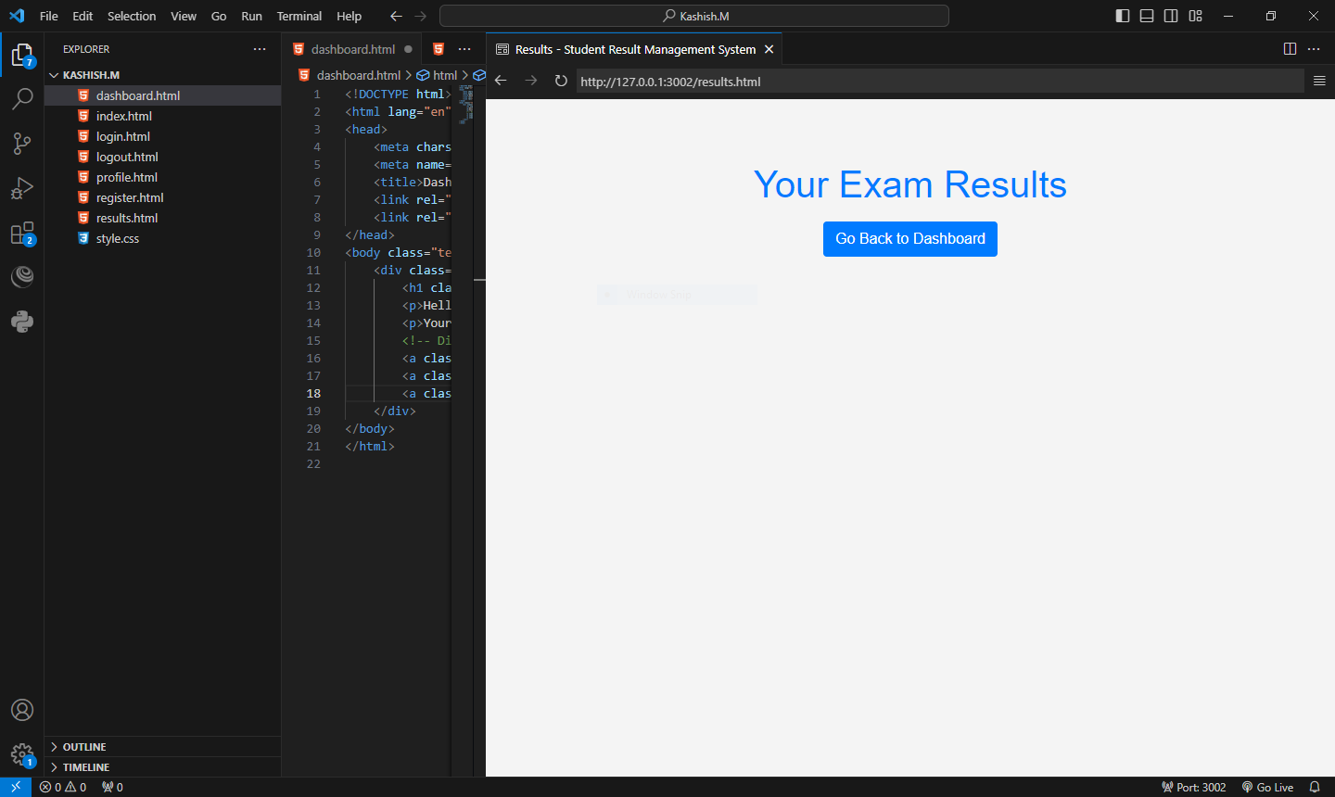

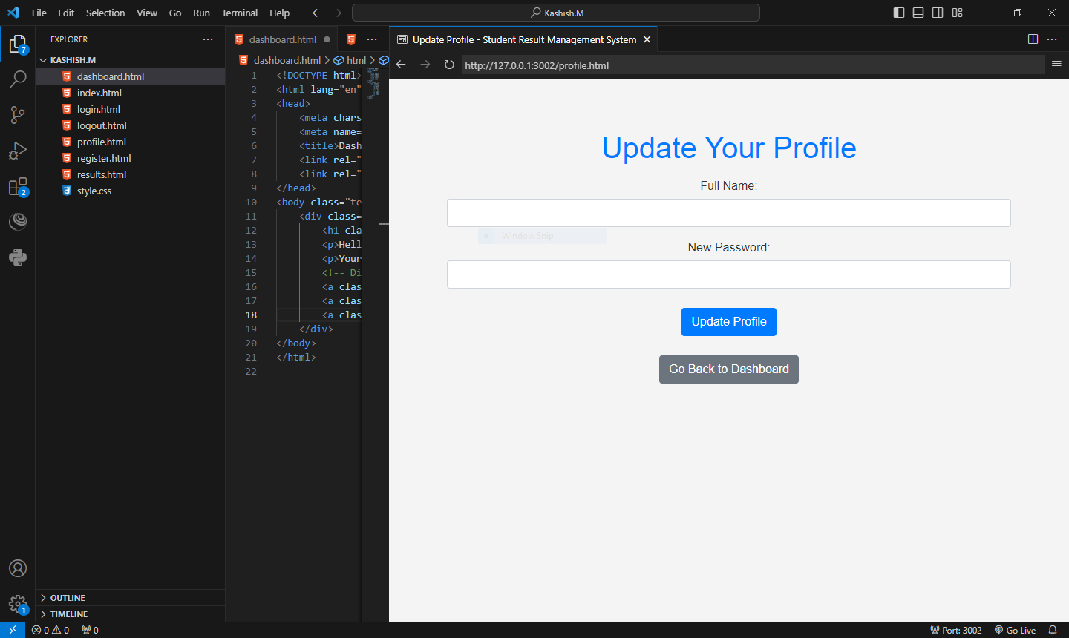

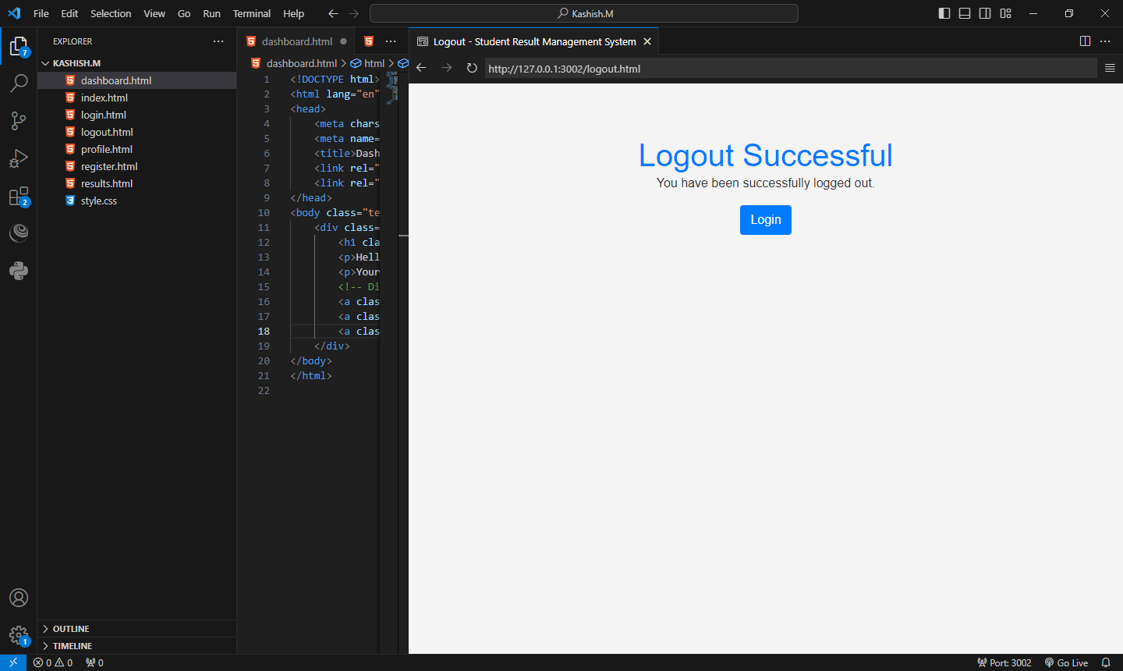

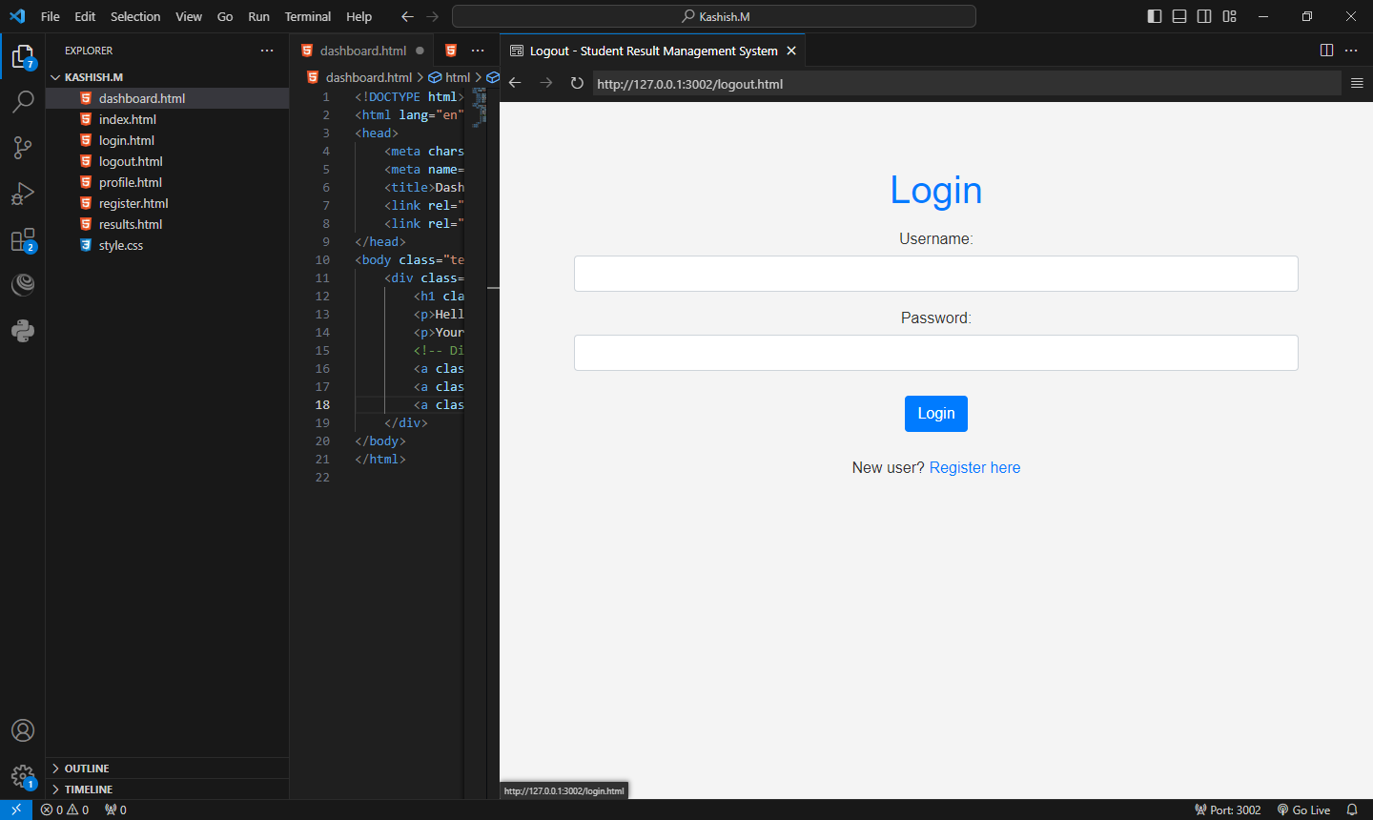

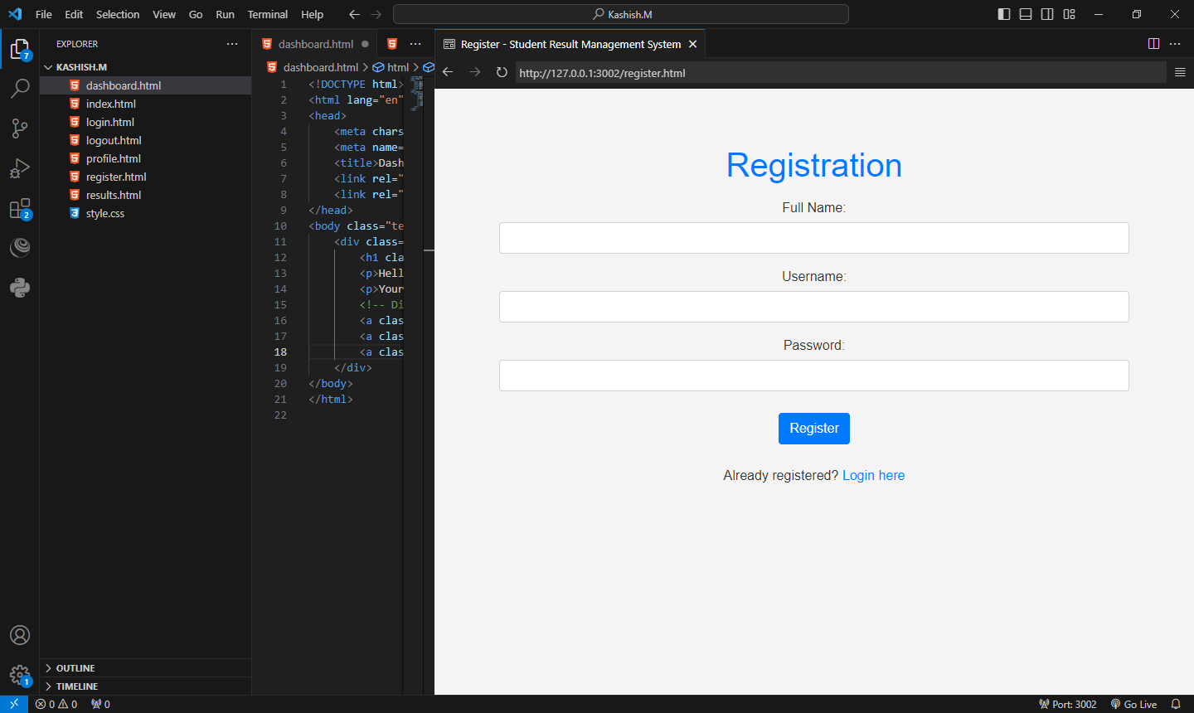

**Post Lab Questions:**

1. **What is the use of containers in bootstrap? Explain in detail.**

**Ans:**

In Bootstrap, a container is a fundamental layout element used to wrap and contain the content on a web page. Containers are used to provide a consistent and responsive layout by managing the width of the content based on the device screen size. Bootstrap offers two main types of containers: .container and .container-fluid.

.container: This class creates a fixed-width container that adapts to different screen sizes. It has a responsive max-width based on the user's device, providing a consistent layout for various screen sizes. It is suitable for websites with a fixed-width design.

<div class="container">

<!-- Content goes here -->

</div>

container-fluid: This class creates a full-width container that spans the entire viewport width. It adjusts its width based on the screen size, making it suitable for fluid or responsive designs.

<div class="container-fluid">

<!-- Content goes here -->

</div>

Benefits of Using Containers in Bootstrap:

1. Responsive Design: Containers help create a responsive layout that adjusts to different screen sizes, providing a consistent user experience.
2. Consistent Padding: Bootstrap containers automatically handle padding and margins, ensuring consistent spacing around the content.
3. Cross-Browser Compatibility: Containers assist in achieving cross-browser compatibility by normalizing and optimizing the display of content.
4. Grid System Alignment: Containers work seamlessly with Bootstrap's grid system, providing a structured layout for organizing content.
5. **Name the classes to achieve the different button styles in bootstrap.**

**Ans:**

|  |  |  |
| --- | --- | --- |
| **.btn** | **Adds basic styling to any button** | [**Try it**](https://www.w3schools.com/bootstrap/tryit.asp?filename=trybs_ref_btn&stacked=h) |
| **.btn-default** | **Indicates a default/standard button** | [**Try it**](https://www.w3schools.com/bootstrap/tryit.asp?filename=trybs_ref_btn-default&stacked=h) |
| **.btn-primary** | **Provides extra visual weight and identifies the primary action in a set of buttons** | [**Try it**](https://www.w3schools.com/bootstrap/tryit.asp?filename=trybs_ref_btn-primary&stacked=h) |
| **.btn-success** | **Indicates a successful or positive action** | [**Try it**](https://www.w3schools.com/bootstrap/tryit.asp?filename=trybs_ref_btn-success&stacked=h) |
| **.btn-info** | **Contextual button for informational alert messages** | [**Try it**](https://www.w3schools.com/bootstrap/tryit.asp?filename=trybs_ref_btn-info&stacked=h) |
| **.btn-warning** | **Indicates caution should be taken with this action** | [**Try it**](https://www.w3schools.com/bootstrap/tryit.asp?filename=trybs_ref_btn-warning&stacked=h) |
| **.btn-danger** | **Indicates a dangerous or potentially negative action** | **[Try it](https://www.w3schools.com/bootstrap/tryit.asp?filename=trybs_ref_btn-danger&stacked=h" \t "_blank)** |
| **.btn-link** | **Makes a button look like a link (will still have button behavior)** | [**Try it**](https://www.w3schools.com/bootstrap/tryit.asp?filename=trybs_ref_btn-link&stacked=h) |
| **.btn-lg** | **Makes a large button** | [**Try it**](https://www.w3schools.com/bootstrap/tryit.asp?filename=trybs_ref_btn-lg&stacked=h) |
| **.btn-sm** | **Makes a small button** | [**Try it**](https://www.w3schools.com/bootstrap/tryit.asp?filename=trybs_ref_btn-sm&stacked=h) |
| **.btn-xs** | **Makes an extra small button** | [**Try it**](https://www.w3schools.com/bootstrap/tryit.asp?filename=trybs_ref_btn-xs&stacked=h) |
| **.btn-block** | **Makes a block-level button (spans the full width of the parent element)** | [**Try it**](https://www.w3schools.com/bootstrap/tryit.asp?filename=trybs_ref_btn-block&stacked=h) |
| **.active** | **Makes the button appear pressed** | [**Try it**](https://www.w3schools.com/bootstrap/tryit.asp?filename=trybs_ref_btn_active&stacked=h) |
| **.disabled** | **Makes the button disabled** | [**Try it**](https://www.w3schools.com/bootstrap/tryit.asp?filename=trybs_ref_btn_disabled&stacked=h) |
| **.navbar-btn** | **Vertically aligns a button inside a navbar** |  |

1. **Write details about the Bootstrap Grid system.**

**Ans:**

The Bootstrap Grid System is a responsive, mobile-first grid system that facilitates the creation of flexible and dynamic layouts. It is based on a 12-column layout, allowing developers to create complex structures by combining different column classes.

Key Concepts:

1. Container:
   * Containers are the outermost elements that hold the grid system. They can be either fixed-width (container) or full-width (container-fluid).
2. Rows:
   * Rows are placed inside containers and act as horizontal wrappers for columns. Rows ensure proper alignment and spacing.
3. Columns:
   * Columns define the layout structure and are placed within rows. Bootstrap provides classes like col-, col-md-, and col-lg- to define the width of

<div class="container">

<div class="row">

<div class="col-md-6">Column 1</div>

<div class="col-md-6">Column 2</div>

</div>

</div>

In this example, the container holds a row with two columns, each spanning half the width on medium-sized screens (col-md-6). The grid system adapts its layout based on the screen size, providing responsiveness.

Advantages of Bootstrap Grid System:

* Responsive Design: The grid system ensures responsive design, adapting to different screen sizes.
* Consistency: It provides a consistent layout structure, making it easy to organize content.
* Flexibility: Developers can create both simple and complex layouts by combining rows and columns.
* Mobile-First Approach: Bootstrap follows a mobile-first approach, prioritizing mobile device styling and then scaling up for larger screens.